CS 255 System Design Document Tanzer

This template lays out all the different sections that you need to complete for Project Two. Each section has guidance to prompt your thinking. You will need to continually reference the interview transcript as you work to make sure that you are addressing your client’s needs. There is no required length for the final document. Instead the goal is to complete each section based on what your client’s needs are. Remove this note when you are finished, and replace all bracketed text with the relevant information.

AI Assistance: Microsoft copilot was used in the making of of this design document. The diagrams and technical requirements list were created using Copilot. They were proofread and where necessary adjusted by the author. The descriptions of each diagram were created by the author without AI assitance.

UML Diagrams

UML Use Case Diagram
Due to the size of the image, it has been moved to the next page. The diagram shows the actors and use cases developed from the business requirements previously laid out. Some use cases, such as detecting and terminating frozen processes and logging errors and crashes, are carried out automatically.
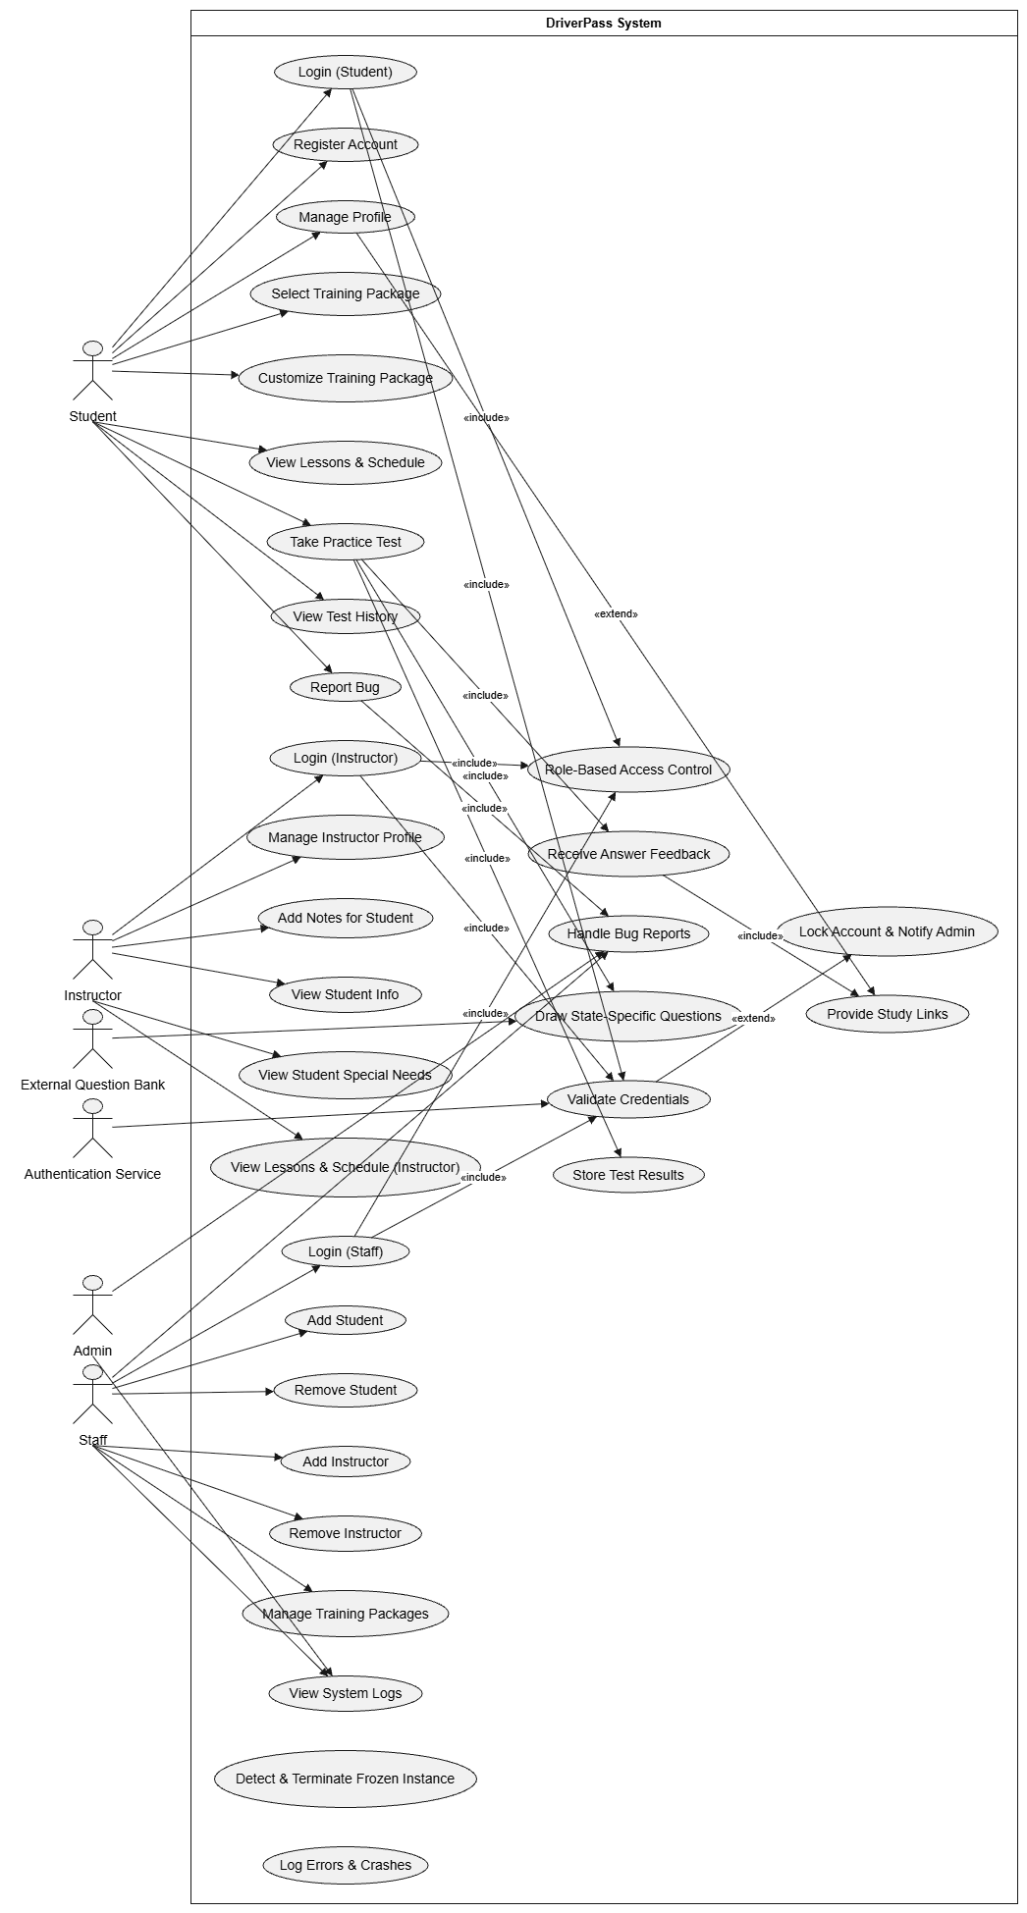

UML Activity Diagrams
As with the Use Case diagram, the two activity diagrams are too large to reasonably fit onto a single page. Therefore, they have been moved to separate pages. Each activity diagram represents a seperate use case.
The first diagram represents the Login use case. Note that there are two timers, a login timer and a locked account timer. The login timer runs for 5 minutes, allowing for most users to retrieve their login credentials without worrying about having to start over. The locked account timer runs for 10 minutes, after which the account unlocks. Because of the low staff numbers, administrator time is at an absolute premium. Therefore, it was decided that forcing the administrator to unlock any locked accounts was a waste of resources. The unlock timer remedies this oversight.
The second diagram represents the Practice Test use case. As can be seen, the activity diagram describes how a student will move through the test. When the student opens the test session, the program retrieves state-specific driving questions. If a student answers the question incorrectly, then the program displays an explanation and provides a link to the relevant study material. After the test is over, the session calculates the score and displays it alongside the last 5 scores. This feature provides the student with feedback as to their progress.
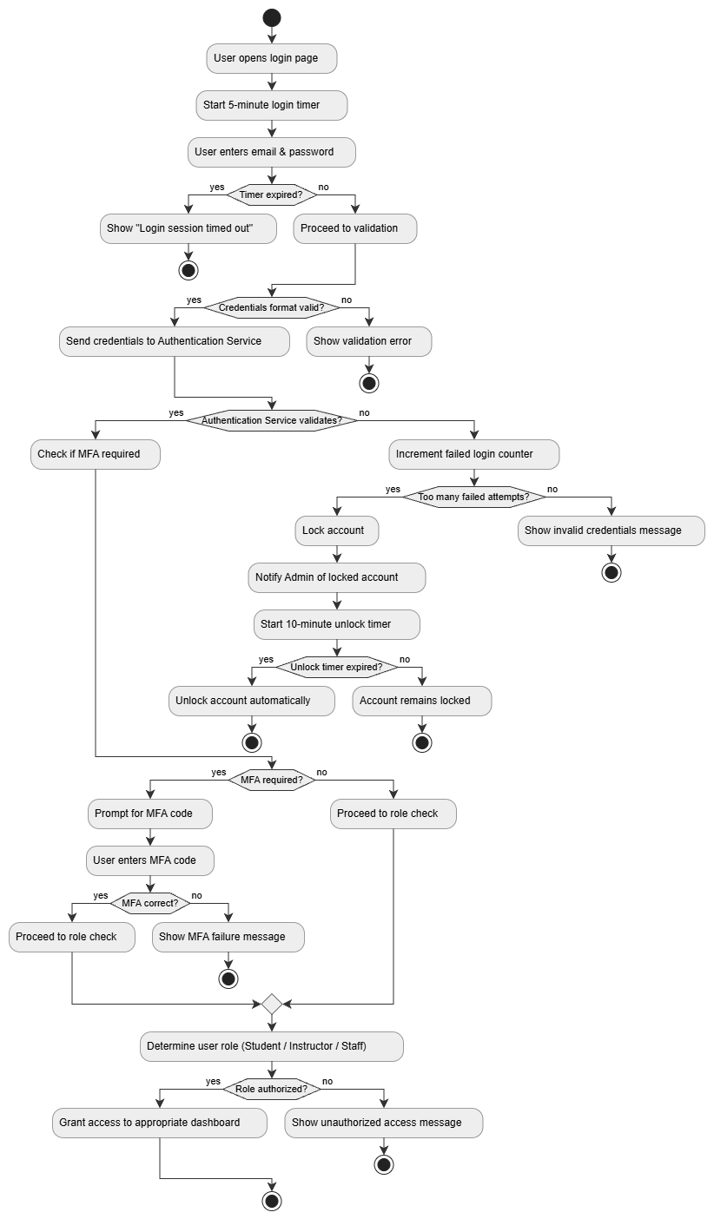
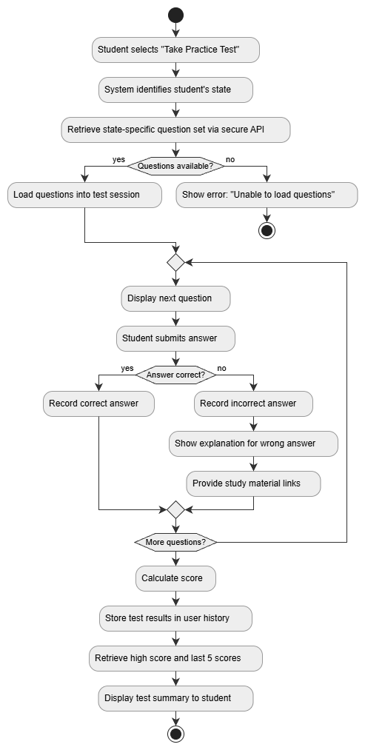

UML Sequence Diagram
The following page contains the sequence diagram for the login use case. It shows how the system handles logins, and notifies the administrator in the event of a locked account. Each communication from the user has a return line with an error message. This prevents users from being kept blind as to why the login failed. While some consider them unnecessary, these return statements are nevertheless a good thing to include, if only for completeness.
The diagram splits the sequence into distinct stages, with each stage handling a separate activity. Most activity states have one or more alternate paths, based on previous events or other conditions. It should be noted that students are not required to have multi-factor authentication (MFA). This is an acknowledgment regarding potential users: not everyone will have access to a MFA app. However, should DriverPass decide at some future time that this limitation no longer is applicable, it is possible to permanently enable MFA for all users, without affecting the role-based access controls.
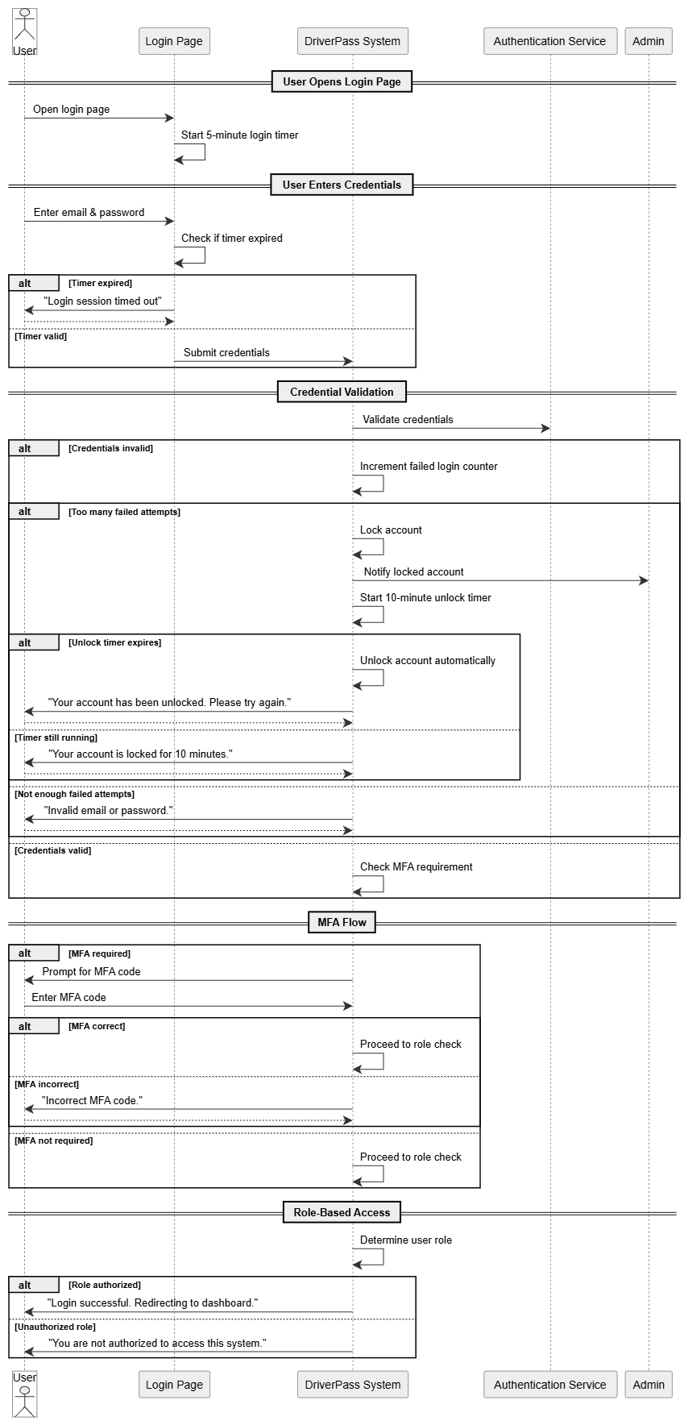

UML Class Diagram

The following image is a class diagram of the DriverPass system. It shows a high-level representation of the system as a whole. As a result, certain aspects of the system have been simplified. The methods and attributes have been excluded, and most classes as represented here may later be expanded into distinct modules.
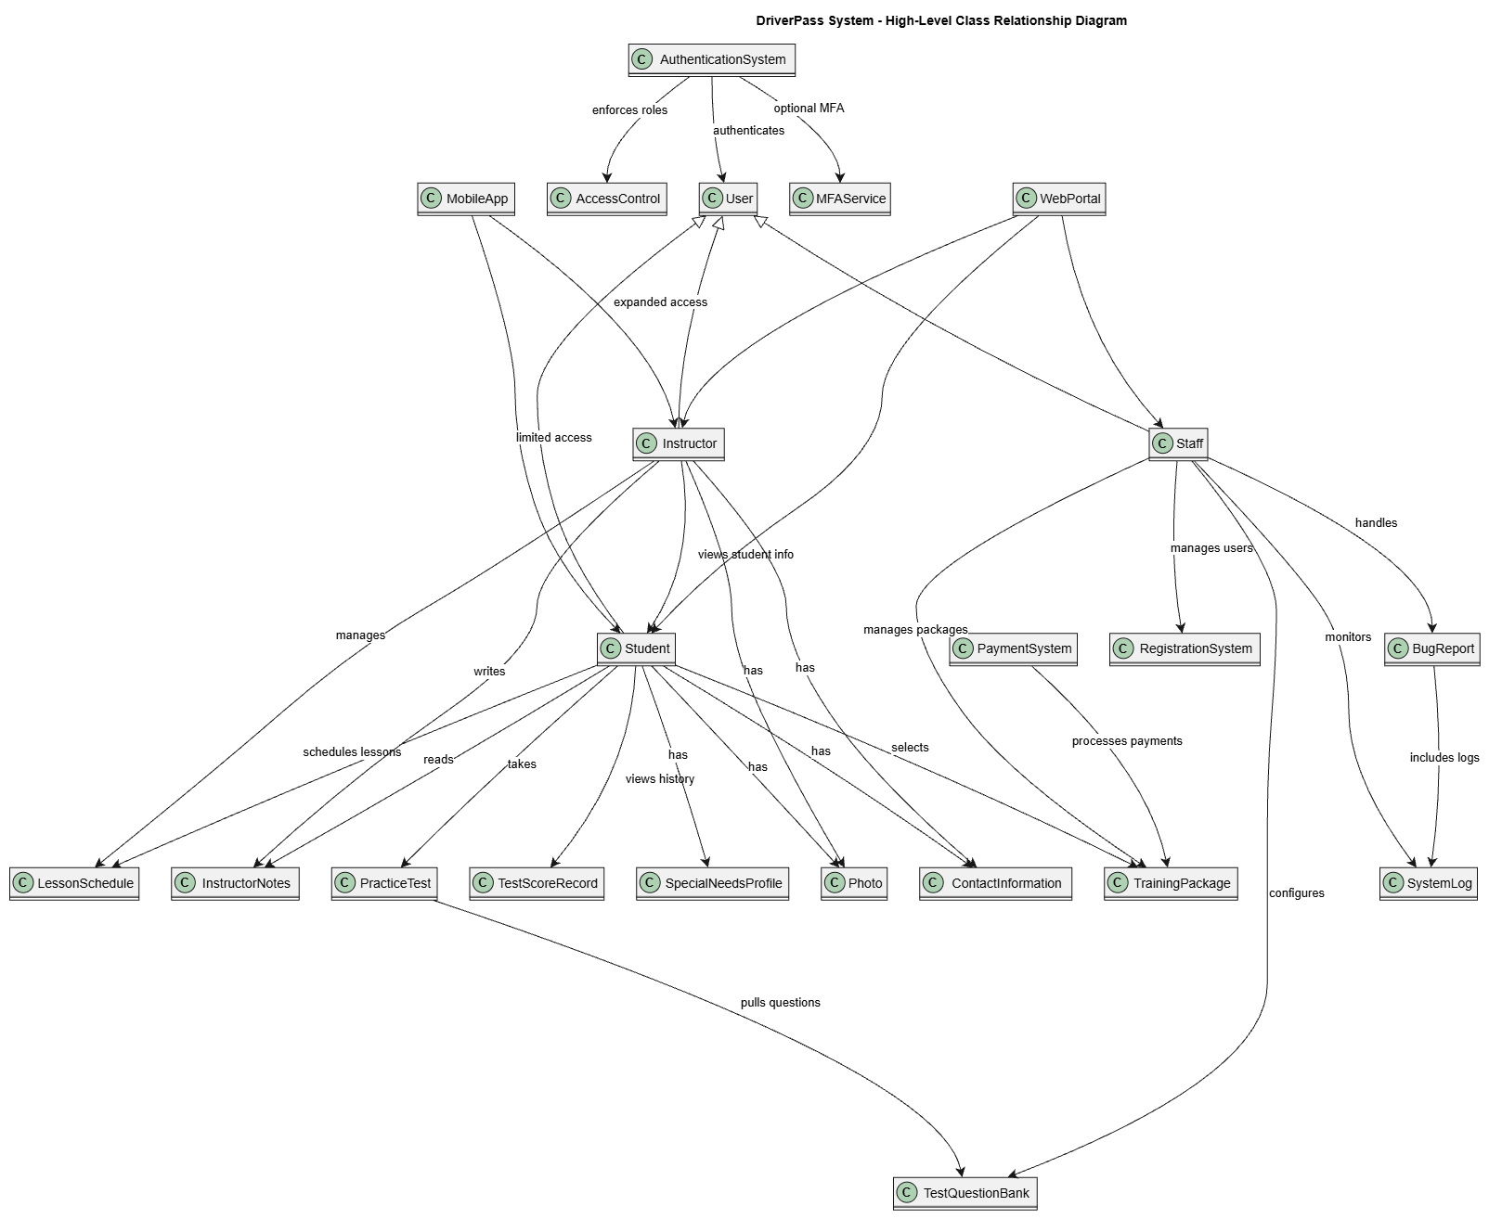

Technical Requirements

SDriverPass Technical Requirements Specification

(Hardware, Software, Tools, Infrastructure — Linux-Container Deployment)

1. Hardware Requirements

Server-Side Hardware
- Cloud-hosted compute nodes (document states: “The system shall be located on a cloud server.” )
- Minimum recommended per container host:
  - 8–16 vCPUs for production workloads
  - 32–64 GB RAM
  - SSD-backed storage (NVMe preferred)
  - Redundant network interfaces (≥10 Gbps internal fabric)
- Load balancer hardware (cloud-managed or virtual)
- Dedicated security appliances (cloud WAF, DDoS protection)
- Optional GPU nodes if image processing (student/instructor photos) requires ML-based optimization.

Client-Side Hardware
- Students, instructors, and staff require:
  - Any modern desktop/laptop capable of running a web browser
  - Mobile devices (iOS/Android) for app access

2. Software Requirements

Operating Systems
- Linux-based container OS (Alpine, Ubuntu LTS, Debian Slim)
- Host OS: Linux (Ubuntu Server, RHEL, or cloud-managed OS images)

Application Software Stack
- Web Server: NGINX or Apache inside container
- Application Runtime:
  - Node.js, Python, Java, or .NET Core (any modern web framework compatible with Linux containers)
- Database:
  - PostgreSQL or MySQL/MariaDB container
  - External DB access via secure API for question banks (document: “Any external databases… will be accessed via secure APIs.” )
- Authentication Services:
  - MFA provider (Auth0, Okta, Azure AD, or custom TOTP)
  - Role-based access control (RBAC)
- Logging & Monitoring:
  - ELK stack (Elasticsearch, Logstash, Kibana) or
  - Prometheus + Grafana
  - Centralized log aggregation for error reporting (document: “The system shall inform the admin of any errors… and provide a log.” )

Front-End Software
- Browser-based GUI (document: “All interfaces shall be a Graphical User Interface (GUI).” )
- Frameworks: React, Angular, Vue, or similar
- Mobile App:
  - Cross-platform (Flutter, React Native)
  - Native iOS/Android optional

Security Software
- RSA-16 encryption for server-to-server communication (document: “the intermediate server and the main server shall use RSA-16 encryption…” )
- DDoS protection (cloud provider or dedicated service)
- Penetration testing tools (weekly requirement):
  - Kali Linux toolset
  - OWASP ZAP
  - Burp Suite

3. Tools Requirements

Development Tools
- Git-based version control (GitHub, GitLab, Azure DevOps)
- CI/CD pipeline tools:
  - GitHub Actions, GitLab CI, Jenkins, Azure DevOps Pipelines
- Container build tools:
  - Docker, Podman, BuildKit
- Code quality tools:
  - ESLint, Pylint, SonarQube

Database Tools
- DB migration tools (Flyway, Liquibase)
- DB admin tools (pgAdmin, MySQL Workbench)

Testing Tools
- Unit testing frameworks (Jest, PyTest, JUnit)
- Integration testing (Postman/Newman)
- Load testing (Locust, JMeter)
- Security testing (OWASP ZAP, Burp Suite)

Deployment Tools
- Kubernetes (EKS, AKS, GKE, or self-managed)
- Helm charts for container orchestration
- Terraform or Ansible for infrastructure-as-code

4. Infrastructure Requirements

Cloud Infrastructure
- Compute cluster for container orchestration
- Managed database service or containerized DB cluster
- Object storage for:
  - Student/instructor photos
  - Instructor notes
  - Logs and backups
- API gateway for:
  - External question bank access
  - Internal microservice routing

Networking
- HTTPS everywhere
- TLS certificates (Let’s Encrypt or cloud-managed)
- Firewall rules enforcing RBAC and MFA requirements
- VPN optional (document warns: “VPNs may cause undesirable and unpredictable interactions…” )

Security Infrastructure
- MFA enforcement for instructors and staff (document: “Instructors and staff must use MFA.” )
- Hardened endpoints against DoS/DDoS (document: “The system shall be hardened against denial-of-service attacks.” )
- Weekly penetration testing environment

Performance Infrastructure
- CDN for static assets
- Caching layer (Redis or Memcached)
- Auto-scaling groups to meet:
  - LCP ≤ 2.5s
  - TTFB ≤ 500ms
  - INP ≤ 100ms (All performance targets come from the document. )

Backup & Recovery
- Automated daily backups
- Disaster recovery region
- Log retention policies (admin error logs required by document)

5. Containerization Requirements (Linux)

Container Architecture
- Multi-container microservices:
  - Auth service
  - Scheduling service
  - Payment service
  - User profile service
  - Instructor notes service
  - Test question service
  - Mobile API gateway
- Containers must be:
  - Stateless
  - Horizontally scalable
  - Built from minimal Linux base images

Security in Containers
- Non-root containers
- Mandatory MFA integration
- RSA-16 encrypted inter-service communication
- Regular vulnerability scanning (Trivy, Clair)

Container Networking
- Service mesh (Istio or Linkerd) optional
- Internal-only communication for sensitive services
- API rate limiting and throttling

6. Infrastructure Access Requirements

Admin Access
- IT admin has access to working code only (document: “The IT admin shall have access to the working code only.” )
- DB access requires authorization from DB manager
- Admin dashboard for:
  - User lockouts
  - Password changes
  - Error logs
  - Bug reports

